

COMMERCE & BUSINESS ADMINISTRATION

COMPUTING STUDIES & INFORMATION SYSTEMS

COMPUTER AND INFORMATION SYSTEMS (PBD)

CSIS 4495-050: APPLIED RESEARCH PROJECT

Mid Term Report:

**End-to-End Data Engineering Solution for HR Analytics**

**Team:** Bruno do Nascimento Beserra | 300392300

Jay Clark Bermudez | 300380540 (Team Leader)

Matheus Filipe Figueiredo | 300389657

**Instructor:** Dr. Bambang Sarif

NEW WESTMINSTER/BC

FALL/2025

## Contents

1.0 Introduction 2

2.0 Project Goal 2

3.0 Methodology 3

4.0 Technical Requirements 5

5.0 Project Plan and Timelines 5

5.1 Phase Overview and Milestones 5

5.1.1 Requirement Analysis and Planning 6

5.1.2 System Design and Modelling 6

5.1.3 Implementation and Development 6

5.1.4 Testing and Validation 6

5.1.5 Deployment, Visualization, and Documentation 6

5.2 Weekly Work Plan and Schedule 6

5.3 Roles and Responsibilities 7

6.0 Project Contract 8

7.0 Work Hours 9

8.0 Acknowledgement 10

9.0 References 10

## 

## 1.0 Introduction

This project looks at a challenge with Dayforce, a SaaS platform used to manage HR data like employee information and payroll. The problem is that Dayforce does not keep historical records. When an employee leaves, their data is deleted, and when updates are made, older records are replaced. This makes it hard to do historical analysis, track workforce trends, or study issues like employee turnover (Dayforce, 2024). This is not just a Dayforce issue, but a common limitation with HR SaaS platforms (Solutions, 2025).

Platform3 Solutions (Solutions, 2025) notes that not keeping payroll and HR records can lead to compliance issues, problems during audits, and even legal trouble. They stress that companies need a clear plan for keeping and archiving data so it stays available when needed and costs stay under control.

Research shows that without strong historical archives, companies struggle with workforce planning and decision-making (Madden, 2025). Using data engineering techniques like Slowly Changing Dimensions Type 2 and platforms like Databricks and Delta Lake can fix this problem by allowing data to be captured, stored, and analyzed over time (WJARR, 2025).

To solve this problem, the project will build a data pipeline that automatically collects, processes, and saves historical HR data. The pipeline will run in Databricks, using Python and PySpark for transformations and Delta Lake for reliable storage. On top of this, a web app will be built with Django and React to show the results of the analysis.

The finished system will help organizations keep and study HR history in a more efficient way. It will make storage use better, allow faster queries, support long-term workforce analysis, and improve decision-making by giving insights that are not possible with the current setup.

## 2.0 Project Goal

The goal of this project is to design and implement an end-to-end data engineering solution that preserves and enables analysis of historical HR data. The project addresses a key limitation in current HR data management, where employee records are deleted after termination or overwritten when changes occur, making historical analysis impossible.

To solve this, the team will develop a data pipeline that ingests daily data from Dayforce and applies data engineering techniques such as Slowly Changing Dimensions (Type 2) to track changes over time, the medallion architecture to structure data into quality layers, and Kimball data modelling to reduce redundancy and simplify queries.

The solution will be built in Databricks using Python, PySpark, and Delta Lake, and will be complemented by a Web application that highlights key workforce metrics using the data available. Together, these components will demonstrate how historical HR records can be effectively preserved, organized, and analyzed to support long-term workforce insights.

## 3.0 Literacy Review

## 

## 3.0 Methodology

As outlined in the project goal, this study will develop an end-to-end data engineering solution to preserve and manage historical HR data. In the corporate world, businesses typically obtain their HR data from platforms such as Dayforce or other human resource management systems. When reports are needed, this data is often exported as a CSV file and analyzed using visualization tools. Since our team does not have direct access to such corporate data, we will use a Kaggle dataset containing information on 2 million employees (Kaggle, 2025), from which we will extract a subset as our sample dataset for this project. This data will be updated monthly, allowing us to track trends over a period of seven years. The pipeline will follow the medallion architecture (Databricks, 2020), with Bronze, Silver, and Gold layers ensuring both quality and traceability.

Figure 3.1 System Architecture

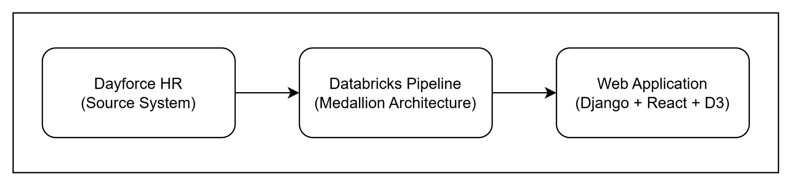

Figure 3.1 shows the overall system architecture. There are three (3) major stages. The raw data from Dayforce will be processed through a Databricks pipeline. Finally, one of the outputs of the system is a CSV file, which will then go through the web application for visualization.

Figure 3.2 Data Engineering Pipeline

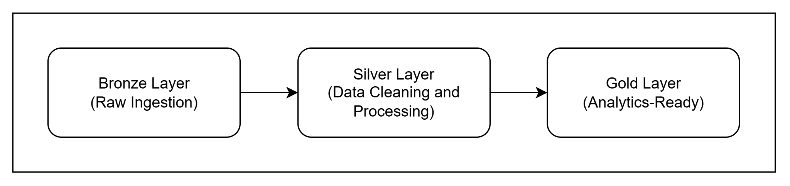

Figure 3.2 shows the data pipeline utilizing Databricks. The process begins with the ingestion of raw employee data from Dayforce (Dayforce, 2020) into the Bronze layer, capturing daily snapshots of the system. Data is then stored in a parquet format. The Silver layer will apply Slowly Changing Dimensions Type 2 (Asanka, 2021) to track historical changes, such as promotions, transfers, or terminations. Data cleaning will address missing values, duplicates, and inconsistent formats, while verifying key identifiers such as employee IDs. Each record will include timestamps and active/inactive flags to maintain historical accuracy.

The Gold layer will structure data for analysis using Kimball modelling (Nguyen, Pham, and Chin, 2020), creating fact and dimension tables to reduce redundancy and simplify queries. Implementation will be carried out in Databricks notebooks with Delta Lake features such as incremental ingestion, schema enforcement, and merge operations to ensure consistency.

Additionally, the output from Gold layer can be readily used for any analytics reports that can be utilized by Tableau, PowerBI, other business needs, and the custom web application developed by the team. This web application will serve as the primary interface for end users to access and explore the visuals.

Figure 3.3 Web Application Architecture

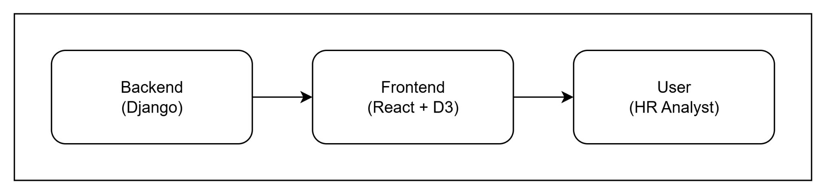

Figure 3.3 shows the architecture of the simple web application that complements with the output from the data engineering pipeline. The backend will use the Django framework, which supports quick development, strong security features, and an organized structure for handling data (Django Software Foundation, 2018). Django will take in the CSV files produced by the Gold layer of the pipeline, process the data, and provide results through APIs that the front end can access.

On the frontend, the app will be developed with ReactJS, since its component-based design makes it easy to update the interface whenever new data comes in (W3Schools, 2017). To make the results more meaningful, we will add D3, a library that specializes in interactive charts and graphs (D3 by Observable, 2020). This allows us to go beyond static visuals and create features like filters, drill-down options, and side-by-side comparisons.

The visualizations will highlight important HR metrics, such as headcount trends, departmental transfers, and payroll history. Presenting this information in an interactive and easy-to-read format will help managers and decision-makers spot patterns, track changes over time, and make better choices using historical data.

Development will follow best practices such as version control in Git (Microsoft, 2022) and thorough documentation. This methodology ensures the solution is robust, maintainable, and scalable, providing a framework that supports both current and future HR data analysis needs.

## 7.0 Work Hours

**Student Name: Bruno do Nascimento Beserra**

| **Date** | **Number of Hours** | **Description of Work Done** |
| --- | --- | --- |
|  |  |  |
|  |  |  |
|  |  |  |
|  |  |  |
|  |  |  |
|  |  |  |
|  |  |  |
|  |  |  |
|  |  |  |

**Student Name: Jay Clark Bermudez**

| **Date** | **Number of Hours** | **Description of Work Done** |
| --- | --- | --- |
|  |  |  |
|  |  |  |
|  |  |  |
|  |  |  |
|  |  |  |
|  |  |  |
|  |  |  |
|  |  |  |
|  |  |  |
|  |  |  |
|  |  |  |
|  |  |  |

**Student Name: Matheus Filipe Figueiredo**

| **Date** | **Number of Hours** | **Description of Work Done** |
| --- | --- | --- |
|  |  |  |
|  |  |  |
|  |  |  |
|  |  |  |
|  |  |  |
|  |  |  |
|  |  |  |

## 8.0 Acknowledgement

We would like to acknowledge our instructor, Dr. Bambang Sarif, for guidance and support throughout the project proposal.

## 9.0 References

Asanka, D. (2021). Implementing slowly changing dimensions (scds) in data ware-

houses. Retrieved from https://www.sqlshack.com/implementing-slowly-changing-dimensions-scds-in-data-warehouses/

Databricks, T. (2020). Medallion architecture. Retrieved from https://www.databricks.com/glossary/medallion-architecture

Dayforce. (2020). Dayforce main website. Retrieved from https://www.dayforce.com/

Microsoft. (2022). What is git? Retrieved from https://learn.microsoft.com/en-us/devops/develop/git/what-is-git

Nguyen, H., Pham, H., & Chin, C. (2020). The analytics setup guidebook. Holistics.

Retrieved from https://www.holistics.io/books/setup-analytics/

D3 by Observable. (2020). What is d3? Retrieved from https://d3js.org/what-is-d3

Django Software Foundation. (2018). Django: The web framework for perfectionists

with deadlines. Retrieved from https://www.djangoproject.com/

W3Schools. (2017). React introduction. Retrieved from https://www.w3schools.com/react/react_intro.asp

Kaggle, T. (2025). Hr dataset (multinational company). Retrieved from https://www.kaggle.com/datasets/rohitgrewal/hr-data-mnc

Dayforce. (2024). Personal data retention policies. Retrieved from https://help.dayforce.com/r/ImplementationGuide/Dayforce-Implementation-Guide/Personal-Data-Retention-Policies

HRBrain. (2024). Hr saas platform analytics and reporting. Retrieved from https://hrbrain.ai/blog/hr-saas-platform-analytics-and-reporting/

Madden, S. (2025). Combating turnover using people analytics. Retrieved from

https://www.scottmadden.com/insight/combating-turnover-using-people-analytics/

Solutions, P. (2025). Payroll data retention management: How to do it right. Retrieved from https://platform3solutions.com/blog/solution-for-keeping-payroll-records-data-retention-compliance/

WJARR. (2025). Developing scalable hr analytics platforms for smes with scd2.

Retrieved from https://journalwjarr.com/sites/default/files/fulltext_pdf/WJARR-2025-2920.pdf